(1)Qn A drawer contains red socks and black socks. When two socks are drawn at random (one by one), probability that both are red is ½. How small can the number of socks in the drawer be?

(Basic Probability)

1. 2
2. 3
3. 4
4. 9

Ans: 4

Solution: (Not so big as it seems) 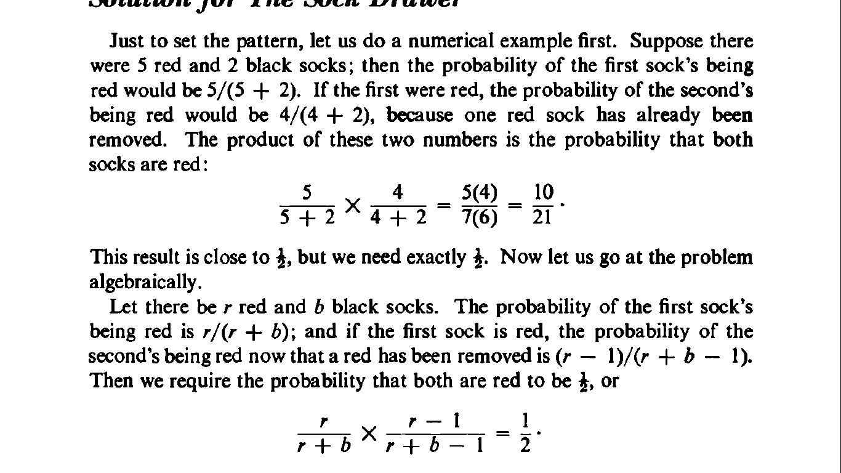

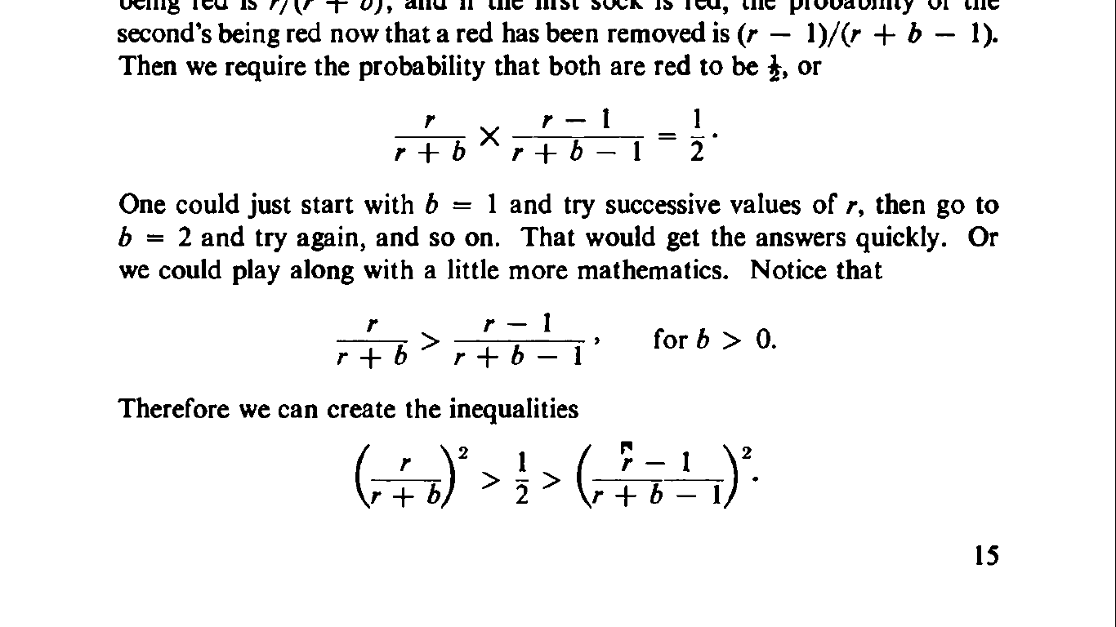

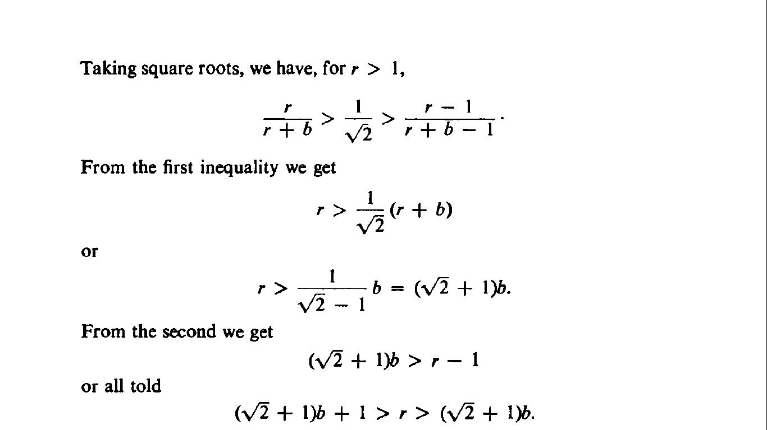

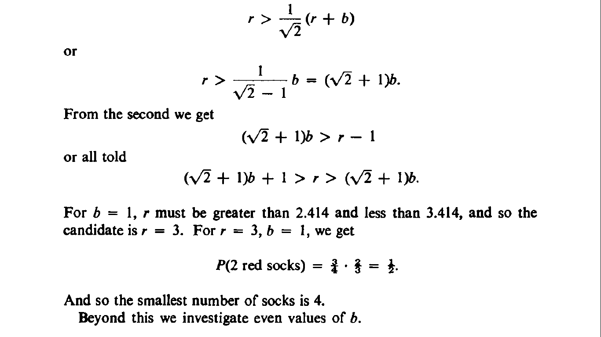

Qn2: Tipli and Pikli are a married couple (don’t ask me who he is and who she is)

They have two children, one of the child is a boy. Assume safely that the probability of each gender is 1/2.

What is the probability that the other child is also a boy?

1. 1/5
2. 1/2
3. 1/3
4. 1/4

Soln:

1/3

This is a famous question in understanding conditional probability, which simply means that given some information you might be able to get a better estimate.

The following are possible combinations of two children that form a sample space in any earthly family:

Boy - Girl

Girl - Boy

Boy - Boy

Girl - Girl

Since we know one of the children is a boy, we will drop the girl-girl possibility from the sample space.

This leaves only three possibilities, one of which is two boys. Hence the probability is ⅓

Qn3

If a positively (right) skewed distribution has a median of 50, which of the following statement is true?

A) Mean is greater than 50

B) Mean is less than 50

C) Mode is less than 50

D) Mode is greater than 50

E) Both A and C

F) Both B and D

Answer:

Below are the distributions for Negatively, Positively and no skewed curves.

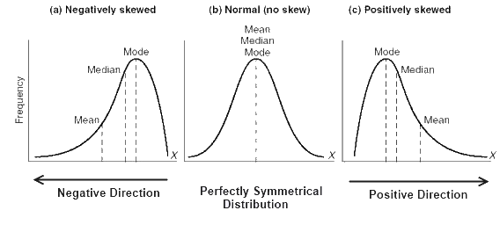

As we can see for a positively skewed curve, Mode<Median<Mean. So if median is 50, mean would be more than 50 and mode will be less than 50.

Qn4

A roulette wheel has 38 slots – 18 red, 18 black, and 2 green. You play five games and always bet on red slots. How many games can you expect to win?

(a)0.0238

(b)2.3684

(c)0.0473

(d)1.279

Soln

The probability that it would be Red in any spin is 18/38. Now, you are playing the game 5 times and all the games are independent of each other. Thus, the number of games that you can win would be 5*(18/38) = 2.3684

Qn5 A primitive village follows a strange custom. They have babies only to have a boy. Whenever a boy is born in a family, they stop having babies and whenever a girl is born, they have a baby again and again till a boy is born.

The probability of having a boy is same as the probability of having a girl. What will be the proportion of boys to girls in the village after some time?  
(a) 1:2  
(b)2:1  
(c)1:1  
(d) None

Soln:  
1:1 (approx)  
Explanation:  
We know that the probability of having a boy or having a girl is same and thus, half of the couples will stop after having a boy child. Half of the others will have a girl and will have a baby again. Out of those half of the couples, half will have a boy and will stop and half will have a girl again. This will keep on going like this.  
Now, if there are X number of couples, there will be X boys.  
1/2 have a boy and stop: 0 girls  
1/4 have a girl, then a boy: X/4 girls  
1/8 have 2 girls, then a boy: 2*X/8 girls  
1/16 have 3 girls, then a boy: 3*X/16 girls  
1/32 have 4 girls, then a boy: 4*X/32 girls  
…  
Total: X boys and  
1X 2X 3X 4X  
– + – + – + — +… = ~X  
Therefore, the proportion of boys to girls will be extremely close to 1:1

Qn:6

A fly has a life between 4-6 days. What is the probability that the fly will die at exactly 5 days?

1. ½
2. 1
3. 3/4
4. None of these

Ans: (d) Probability is 0

Soln:Here since the probabilities are continuous, the probabilities form a mass function. The probability of a certain event is calculated by finding the area under the curve for the given conditions. Here since we’re trying to calculate the probability of the fly dying at exactly 5 days – the area under the curve would be 0. Also to come to think of it, the probability if dying at exactly 5 days is impossible for us to even figure out since we cannot measure with infinite precision if it was exactly 5 days.

Qn7: Which of the following is true

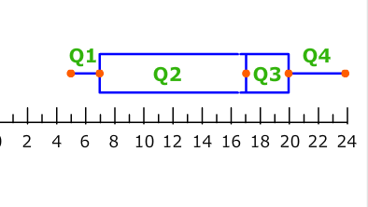

1. There are more points in Q2 than Q3
2. The distribution is right skewed
3. There are fewer data in points in Q1 than Q4
4. None of the above.

Soln:

(d)

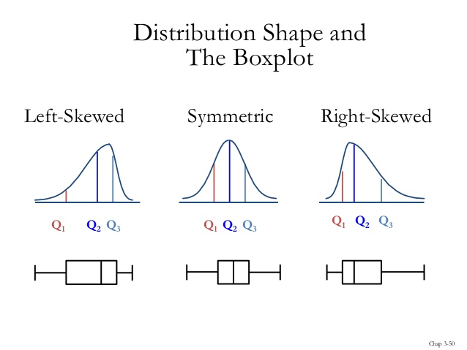

Programming que(R)

8 .list1 <- list(c("c++","c","s"), matrix(c(1,2,3,4,5,6), nrow = 2),

list("red",20.3,4.3,6.3,8.6),c('R','Python','SAS'))

Find the following output list1[[3]][[2]] ?.

Soln :20.3

It will select the second element of the list which is indexed third inside the main list .

9. **y <- 3**

**f<- function(x) {**

**Question 2 : Scoping Rules**

**y<-2**

**y^2 + g(x)**

**}**

**g<-function(x)**

**{**

**x*y**

**}**

**What is the value of f(6) ?**

**soln:**If you answered anything other than 22, you probably need to refresh the lexical scoping in R. The function f(x) returns a value y^2 + g(x). y in this environment has been defined as 2 and g(x) from inside this function. The value of x is passed of function g as 6. Now comes the catch, what is the value of free variable y here? Unlike dynamic environment where the value is assumed from the parent environment, lexical scoping assumes the value of a variable from the environment where the function is defined. The function g(x) is defined in the global environment here, and hence the value of y is assumed to be 3. Therefore a value of 18 is returned from the function g(x). f(6) is finally returning as 22.

**Python Que 8) To get the list of all the distinct values you can simply use the command .unique() . In this case train.Education.unique. Ans - c**

**Python Que 9) Imputing missing values is one of the most important Preprocessing steps. In the presence of missing values, most of the ML Algorithms work. To get the No of missing values you can use the command .isnull().sum()**

**In this case (train.isnull().sum()).LoanAmount**

**Ans- c**